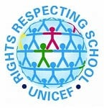





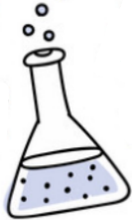
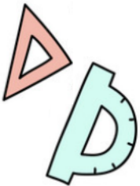
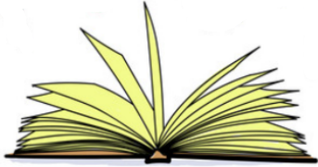
RRS
As a Rights Respecting School, some of the Articles that we will be focusing on this term include:
Article 12 Every child has the right to have a say in all matters affecting them, and to have their views taken seriously.
Article 13 Every child must be free to say what they think and to seek and receive all kinds of information, as long as it is within the law.
Article 9 Children must not be separated from their parents against their will.

Lydgate Junior School
Curriculum Overview
Year 6 Autumn term
Enrichment Activities
12/9/24 National Holocaust Centre
16-27/9/24 Bikeability
Science visits to King Edward’s School
26/11/24 Shakespeare Company
Art & Design Technology
In art, we will look at the origins and impact of Painted Fabrics (a company for injured WWI ex-servicemen in Sheffield). We will study collagraphs and create
our own blocks of textured materials to print
onto fabric inspired by WWII. In DT, we will
design and create our own light boxes.

Other Subjects
Computing – Word processing, safe searching and Scratch maze game
PE – Volleyball and gymnastics, followed by Netball and WWII dance
Music – Music in WWII (focus on Glenn Miller)
RHE – Stereotypes, prejudice and where we get information from.
Mandarin – Mid Autumn Festival
Religious Education
We will find out about the importance of creation and study Genesis 1. We will find out how different Christians may interpret this text and decide whether it is conflicting or complementary with what science says. Then we will learn about differing beliefs across the world.
History
We will study WWII through the eyes of different people. We will learn how WWII started and, over the course of the unit, the children will research how the war affected the lives
people in Sheffield, across Britain and in different
# countries and circumstances. This, in turn, will give a
wider perspective of Britain’s role in world history.
We will then move onto our Geography topic:
Extreme Environments.

Science
Electricity is our topic for this term.
We will recap what we know about
it and learn about the history of electricity, as well as some important figures (such as Lewis Latimer). We will complete circuit building challenges, learn how to use circuit symbols to represent components and investigate the relationship between them. Finally, we will apply what we have learned to design and build our own Morse code machines.
Maths
We are starting with place value and will
then move onto the four calculations
(addition, subtraction, multiplication and
division). Following this, we will work on ordering and calculating with fractions, which will lead into working with decimals. We will order decimals as well as practise multiplying by 10, 100 and 1,000. Finally, we will learn about percentages, which will include looking at fraction, decimal and percentage equivalents as well as finding percentages of amounts.
English
In SPaG, we are revising word classes, sentence types, clauses and conjunctions. Then we will learn about modal verbs, parenthesis and the subjunctive form. We will revise basic punctuation (capital letters, full stops and commas) and make sure that we are accurately punctuating our speech. We will ensure the consistent and correct use of tense throughout all pieces of writing. We will apply these skills to our writing, which will have pieces inspired by our topic work, such as: a missing person’s report and writing as an evacuee. We will also write poems, a suspense story and a diary entry
based on Macbeth. Finally, we will write a
biography about Mr Frostbite.

The theme for this term is…
WWII through different eyes

